

**3rd Year Project Proposal**

**Student Name: Student Number:**

Christopher J. Costelloe K00233369

Kevin Dunne K00232599

Jekaterina Pavlenko K00224431

**Programme:** Computing

**Working Title:** PathFinder

**Description:**

An App (Android Phone or Tablet), that allows a user to find their way around supported buildings and / or areas, so if a user entered into a building such as LIT they could download the app and instantly have access an interactive map of LIT which has the ability to display all room names, number and specific information about those rooms such as timetables etc.

This example gives an idea of what our app will be able to do such as display different room locations on a map and a path that the user can follow to reach there intended room following an optimal path.

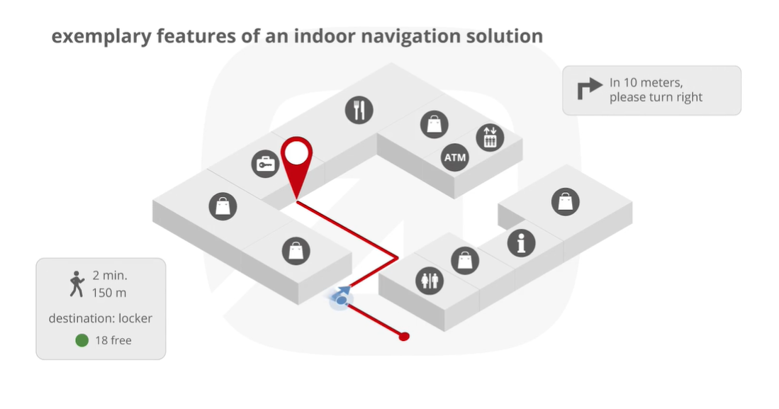

Figure 1 Insoft.com indoor GPS app

One of the ways we plan to do this is to have specific sensors laid throughout LIT which can communicate with our device to actively track the user in the building so our app can find there selected room and lead them to it or we will use a specific area of the LIT building and just show where we are in that room and set a path in it to show we can use our app as a pathfinder.

There is also another aspect to our app we will have the ability to implement which involves using analytics to find optimal paths to different areas of the building and it has the potential to become part of a smart building network in the future.

**Reasons for selecting project**:

Stop people from getting lost in places where the application is installed / supported.

As we know, GPS doesn’t work well indoors, so we want to figure out some indoor navigation system that will work like GPS.

We want to find efficient, convenient and cheap way to do this, by trying to use different technologies or even mixed them up to raise accuracy of our navigation system. We want to help people to navigate independently in such places as hospitals, airports, etc with less stress and reach their destination as fast as possible, especially, when they are in a rush. Also, this app might ease life to people with disabilities by helping to find the best route for them, to get on 2nd floor, in example.

**Proposed research content:** Software for navigation of buildings and path trails / walkways.

**External links (if applicable):** None

**Hardware requirements:** Back-end server (SQL Database/Web Server), PC, Android Mobile Phone / Tablet, potentially: NFC tags, Bluetooth beacons, QR codes, Barcodes and other types of sensors / inputs.

**Software requirements:** SQL server, Java, HTML, CSS, PHP, Java Servlets, C++, Python

**Other requirements:**  undetermined at this moment

**Signed:** ________________________________

**Date:** 15/9/19

**For Office Use Only**

Approved/Not Approved: _________________________________

Reasons for not approving project: _______________________________________________________________________________________________________________________________________________________________________________________________________________

Conditions attached to approving project: _______________________________________________________________________________________________________________________________________________________________________________________________________________

Name of supervisor: ____________________________________________________

Signed: _____________________________ Date: __________________